**06 - 3D TGV**

3D TGV was used to quantify the time evolution invariants as JCP. Although invariants are stable they present high-frequency oscillations and need further analysis.

This TGV is defined with the following initial conditions. rho = U_0 = 1, P_0 = 100 and a domain of 2pi^3 with 32^3 mesh.

u = sin(2*pi/3).*sin(X).*cos(Y).*cos(Z);

v = sin(-2*pi/3).*cos(X).*sin(Y).*cos(Z);

w = u*0;

P = P_0 + (1/16).*((cos(2*X) + cos(2*Y)).*(cos(2*Z) + 2) - 2);

T = P./(rho_0.*R_specific);

It does not have analytical solution, and in fact, smaller and smaller scales are generated by the non-linear Navier-Stokes term. Since there is no viscosity to regularize the flow, after a sufficiently long time there will be just a chaotic flow.

The results presented below are at CFL = 0.1 and define U_ref for the delta time considering U_0 (not 3D components) + sos.

1. **Pressure and velocity field at XY section at mid Z-plane.**
   1. At t = 0.1s

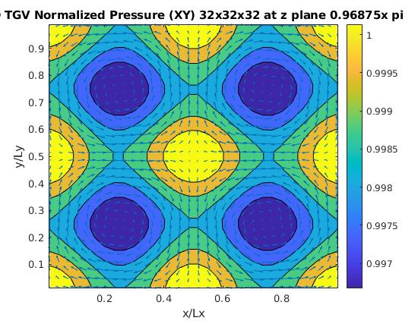

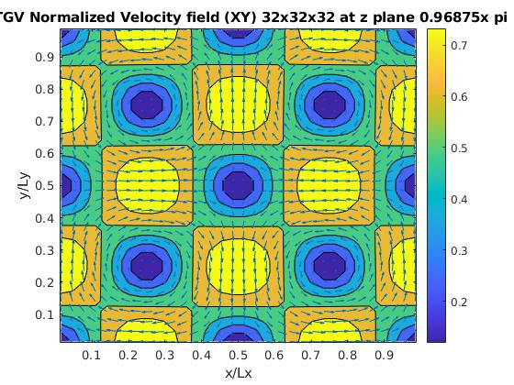

* 1. At t = 100s.

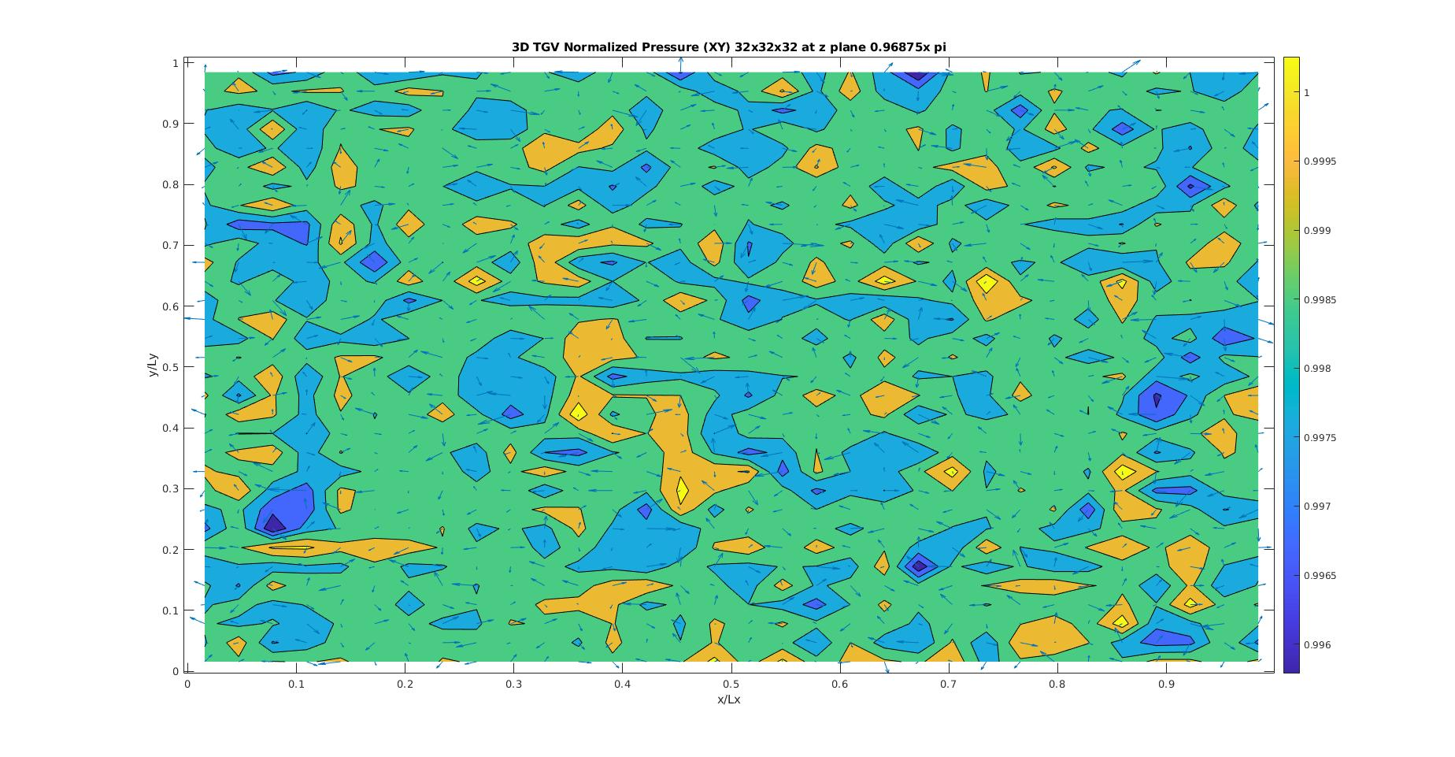

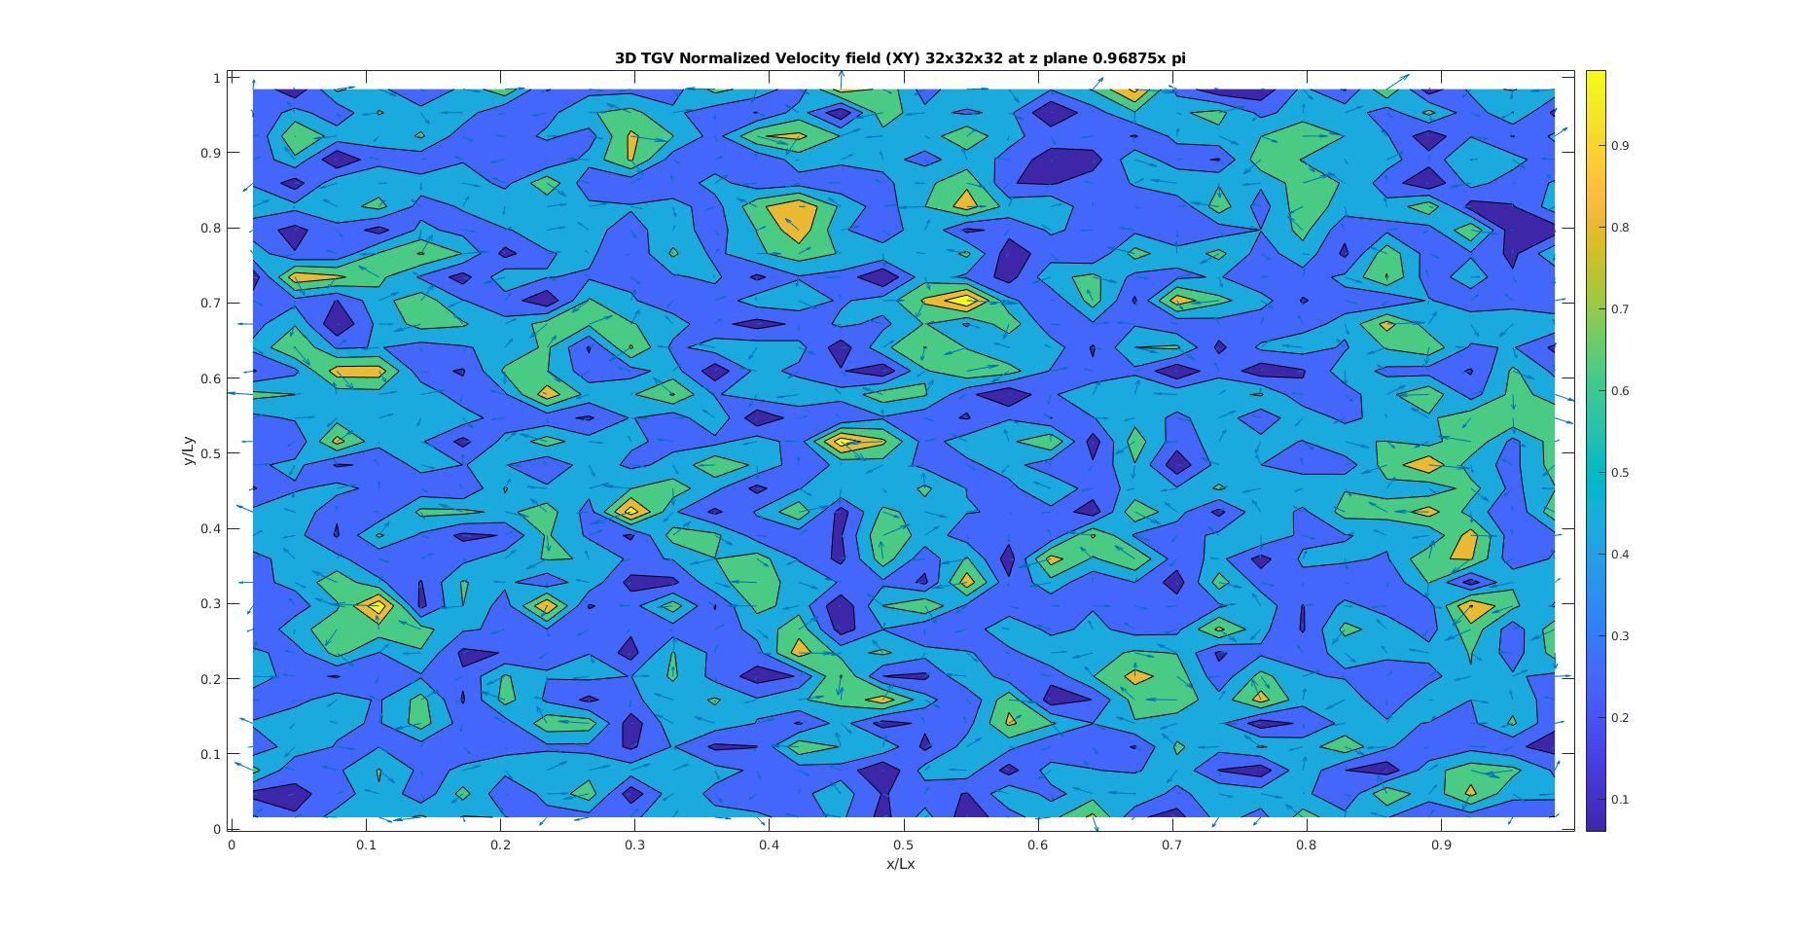

1. **Invariants**
   1. At t = 0.1s

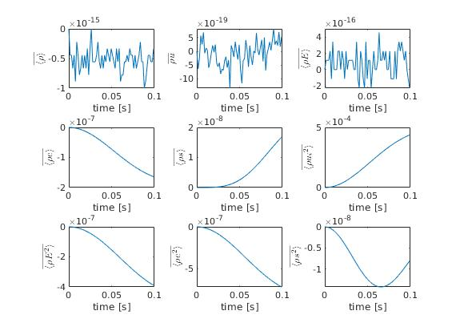

* 1. At t = 100s

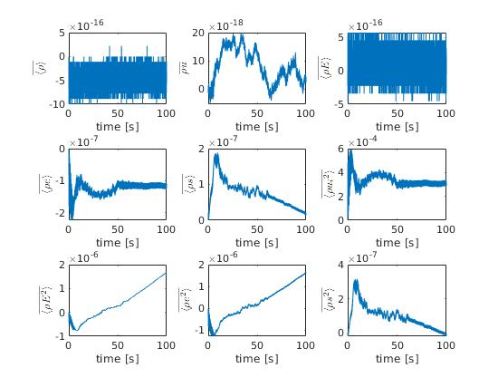

1. **Kinetic energy**
   1. At t = 0.1s

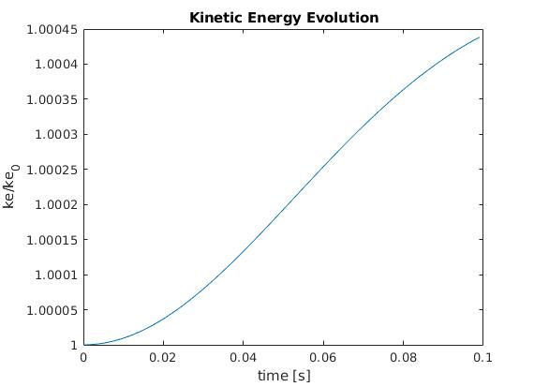

* 1. At t = 100s

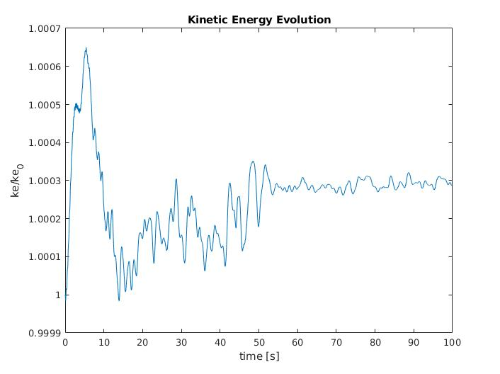

* Results with CFL based on high temperature and therefore time step low

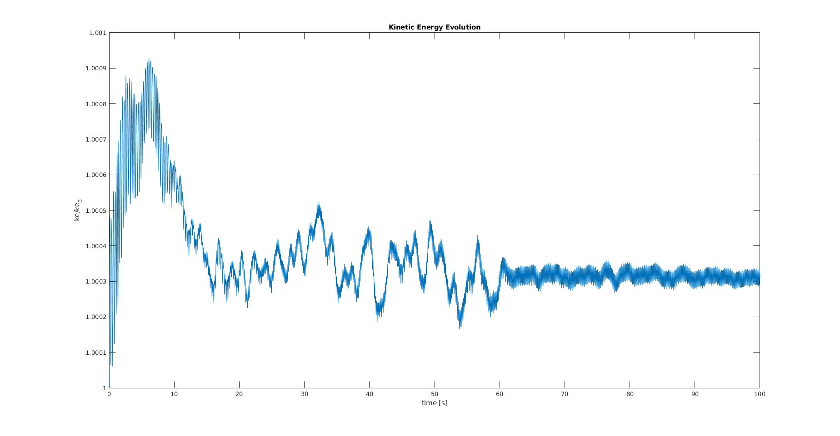

1. **Comparison with JCP reference**
   1. Invariants at t = 100s and CFL = 0.1

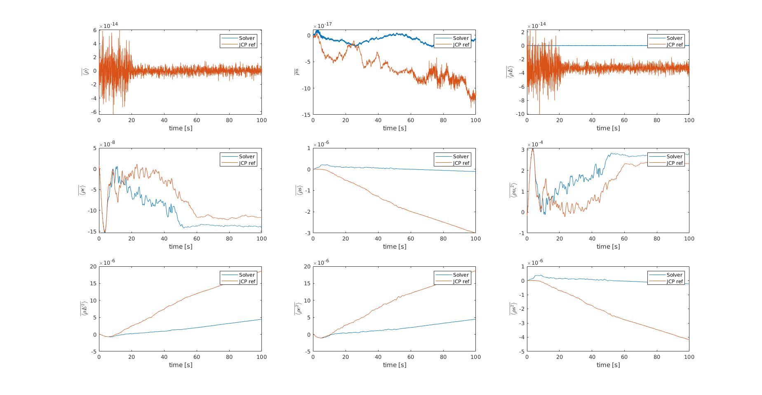

* 1. Ke comparison 5sec with TGV FFT solver

